Blended Learning: Middle School Students’ Perspectives
by
Chad J. DeWolf

TABLE OF CONTENTS
Page
Chapter
1 | ORIENTATION TO THE PROBLEM ……………………………………  Statement of the Problem ………………………………………………….  Statement of Purpose ………………………………………………………  Research Question …………………………………………………………  Theoretical/Conceptual Framework ……………………………………….  Significance ………………………………………………………………..  Definition of Terms ………………………………………………………..  Summary ………………………………………………………………….. | 1  1  2  3  4  5  5  6
2 | REVIEW OF THE LITERATURE ………………………………………..  Transitioning to Blended Learning: Understanding Student and Faculty Perceptions ………………………………………...………………………  Blended learning and teaching writing: A teacher action research project...  Summary ………………………………………………………………….. | 7  7  8  9
3 | METHODOLOGY ………………………………………………………...  Research Design …………………………………………………………...  Bounds of Case …………………………………………………………….  Participants ………………………………………………………………...  Research Context …………………………………………………………..  Researcher Background and Role …………………………………………  Data Collection …………………………………………………………….  Survey ……………………………………………………………………...  Interviews ………………………………………………………………….  Audiovisual Materials and Documents ……………………………………  Data Analysis Procedures ………………………………………………….  Reliability and Validity/Credibility and Consistency ……………………..  Ethical Considerations ……………………………………………………..  Summary ………………………………………………………………….. | 10  10  11  12  13  13  15  16  17  18  18  20  21  22
4 | DATA PRESENTATION …………………………………………………  Survey Results …………………………………………………………….. | 23  24
5 | DISCUSSION ……………………………………………………………..  Conclusions ………………………………………………………………..  Implications ………………………………………………………………..  Recommendations ………………………………………………………… | 27  27  28  29

References ………………………………………………………………………... | 31
Appendix A - Initial Email to Contact Participants …...……………………………  Appendix B - Informed Consent ………………………………………………...…  Appendix C - Interview Prompts ………...…………………………………………  Appendix D - Interview Transcripts ……..…………………………………………  Appendix E - Observation Notes ……………...……………………………………  Appendix F - Sample Document …………………………………………………...  Appendix G - Interview Transcripts (Coded) ………………………………………  Appendix H - Observation Notes (Coded) …………………………………………  Appendix I - Sample Document (Coded) ………….……………………………….  Appendix J - Code Book ………………...……………………………………...….  Appendix K - Patterns in the Data …….……………………………………...……. | 32  33  34  35  40  41  42  46  47  48  49

CHAPTER 1

Orientation to the Problem
Challenging each student to not only reach, but achieve his or her greatest potential is what each teacher should strive for when educating. School systems try to ensure that the teachers in their district have the tools and training necessary to engage each student throughout his or her educational exploration. But, what if school districts are looking at the wrong possible solutions due to a limited means of thinking about the best ways to educate today’s students? What if improving student learning and achievement directly aligns to the integration of 21st Century, Web 2.0 tools embedded into a curriculum that effectively implements a blended learning environment? Blended learning refers to the integration of classroom face-to-face learning experiences with online learning experiences (Garrison and Kanuka, 2004). Students not only learn with their classmates in a school setting, but use online resources to catch students up or even accelerate their learning experience. There are many dependent variables that are directly related when looking at traditional models of education and a complete online model of instruction, both of which created the rise of a blended learning environment. A blended learning environment is geared to take the best of the traditional model and combine it with an online model of student learning. Is blended learning, in a middle school environment, just another shiny example of an educational fad, or can it provide solutions to problems of today’s teachers and student learners?

Statement of the Problem
Educational technology is here to stay. The problem in today’s classrooms is when to use it, how to implement and integrate it, and with some, why it is even necessary at all. Although blended learning could be a positive solution to improve student learning, negative perceptions held by members of academic staff could affect the adoption of blended learning (Oh and Park, 2009), which would alter student perceptions on a well laid out implementation of the blended learning environment. Forgetting about the staff for a second, we really need to speak with the students and ask them if the integration of educational technology assists them in their learning process. We are not asking the students if mixing, or blending, the educational technology is helpful or hurtful to their overall understanding of the content to be mastered. Do students in a middle school setting believe that blending educational technology with face-to-face learning styles help, or hurt the overall goal that teachers have, which is to improve student learning and achievement? We need to identify their perceptions of a blended learning model to gain an understanding of how the student him/herself views this model, regardless of what the members of academic staff’s perceptions are.
Addressing challenges of middle school students working within a blended learning environment, the researcher plans on conducting research in the forms of observations, surveys, and interviews with a set of students in a middle school setting. The researcher will also collect artifacts from blended learning lessons as a part of the data collection process. This will help me understand if a blended learning environment adds anything special or unique to the learning process of middle school students. It is essential, with the usage of technology in today’s classroom setting, to understand the perceptions of middle school students’ perceptions of blended learning.

Statement of Purpose
Typically, blended learning is the use of diverse information transfer methods together and in some occasions within a learning methodology (Sloman, 2003). The purpose of this study is to identify middle school students’ perceptions on a blended learning environment. It is essential to understand what the students are thinking and feeling when it comes to their own learning and achievement. Teachers are expected to make learning relevant and rigorous for students. Far too often teachers do not probe the students if their learning was relevant or rigorous in any way. By identifying a student’s perspective on the type of learning (blended learning) and how it affected their learning outcomes, educators can better understand what middle school students think about the student learning process in a blended learning environment.

Research Question
This research study is focusing on one simple and direct question. I am targeting 8th grade middle school students who are already in a blended learning environment to determine what their overall perceptions are. The following is my research question:

- How do middle school students perceive a blended learning environment?

The concept of blended learning is derived from two words, blend and learning. The word blend means combining things and learning denotes an assimilation of new knowledge as explained by Olivier and Trigwell (2005). This entire research process is designed to understand the students’ perceptions on these two terms on how they relate to their understanding of their learning environment.

Theoretical/Conceptual Framework
Conceptual framework informs the rest of a research design. It is needed to assess and refine your goals, develop realistic and relevant research questions, select appropriate methods, and identify potential validity threats to your conclusions (Conceptual Framework, 2012). This framework will assist in the understanding of whether or not blended learning can or cannot be beneficial to the student learners. This can be explained by identifying the how and why of blended learning, how it is implemented, and the responsibilities of everyone involved within the learning model. There are currently research studies in the field of blended learning, however, they are mostly at high school and university levels. Northern Arizona University (NAU) offers up roles of the faculty and students and characteristics of successful blended course. NAU also states that their blended learning approach “combines the best elements of face-to-face teaching with a variety of technologies, resulting in increased learning effectiveness and improved efficiency” (Home – Blended Learning, 2013). I believe the information at NAU would parallel with the middle school setting and is relevant to this research study. That being stated, it is only my assumption that there are many dependent variables that need to be made static to create an understanding/solution to these problems in a blended learning environment. Once the functions of these dependent variables are identified and substituted with data driven static solutions, it is my expectation that understanding the how and why of a blended learning model will make it easier to implement with a greater rate of success for the educator and student learner. If more students are invested in real world applications within their relevant and rigorous learning, a greater achievement level can be obtained.
Bonnie Hamilton believes that “the integration of technology with classroom content improves student achievement and thoughtfully planned lessons engage students to a higher degree than traditional teaching, and lead to the development of 21st century skills such as complex thinking, creative problem solving, and collaboration” (IT’s Elementary, 2015). By integrating technology already used by the student learners to further enhance their understanding of content standards within the traditional classroom setting and outside, be it at home or on a bus, it is my theory that the blended learning student will surpass the traditional learner in achievement while cultivating a deeper understanding of their learning. It is also my belief that prepared administrators, teachers, students, and parents play a direct role in the overall success of a blended learning model and all must understand its benefits, challenges, and the possible perceived positive and negative outcomes. Through the conceptual framework, I will “incorporate pieces that are borrowed from elsewhere, use data that is collected, but the overall coherence, is something that will be constructed, not ready made” (Conceptual Framework, 2012).

Significance
The significance of this study is to determine what a middle school student’s perceptions of a blended learning environment are. More specifically, students who are already in a blended learning environment so that they can provide background details from the blended learning environment and comment on the overall benefits, and challenges or problems, that the blended learning environment may have. This will be compelted in a Title 1 school located in a rural town in Georgia, which will also add some significance to the study as well.

Definition of Terms
Blended Learning refers to the integration of classroom face-to-face learning experiences with online learning experiences (Garrison and Kanuka, 2004).
Conceptual Framework is explained that it is primarily a conception or model of what is out there that you plan to study, and of what is going on with these things and why—a tentative theory of the phenomena that you are investigating (Conceptual Framework, 2015).
Integration of Technology is when students are not only using technology daily, but have access to a variety of tools that match the task at hand and provide them the opportunity to build a deeper understanding of content (What is Successful Integration?, 2011).

Summary
The chapter provided an overview of the study to understand the middle school student’s perspectives on a blended learning environment. Today’s students are our future. It is important that we prepare the students in the best possible manner to ensure that each student achieves his or her greatest potential. It is my intention to have a strong understanding of what middle school students perceptions are in regards to a blended learning environment.

CHAPTER 2

REVIEW OF THE LITERATURE
The main research objective of this study is to identify the middle school students’ perspectives on a blended learning environment. The first literature review section is a review of the related literature titled, “Transitioning to Blended Learning: Understanding Student and Faculty Perceptions” by Nannette P. Napier, Sonal Dekhane and Stella Smith (2011) that specifically addresses the research objective: What is the impact of blended learning on students? This literature is directly related to my research study in understanding stakeholder perceptions of a blended learning environment. The second literature review section is a review of the related literature titled, “Blended learning and teaching writing: A teacher action research project” by Faye Marsha G. Camahalan and Andrea G. Ruley (2014). Their research study focuses on middle school students in a blended learning environment that was geared towards writing. This has a direct correlation to my study as the participants from both studies are middle school students with an emphasis on improving the students’ achievement through a blended learning environment.

Transitioning to Blended Learning: Understanding Student and Faculty Perceptions
The main purpose of this literature review on the research titled “Transitioning to Blended Learning: Understanding Student and Faculty Perceptions” by Napier, N. P., Dekhane, S., & Smith, S. (2011) is to document the research of related studies to my topic of blended learning and student perspectives. This particular study of college level students main research question was asking what students perceived as the benefits and challenges of taking blended learning courses. This directly aligns with my research question as to what student perceptions are of a middle school blended learning environment.
The entirety of this research is geared towards student (and teacher) perceptions of blended learning at the college level. The research, although conducted at the college level, is still comparable at the middle school level, as the same challenges for teachers, and students, may be the exact same in nature. The major gap with this research and my research are the participant’s ages (college to middle school). This gap may provide different student perceptions but may also align both research studies as common perceptions for all students from the middle school to college level students.

Blended learning and teaching writing: A teacher action research project
The research of Camahalan and Rutley (2014) titled “Blended learning and teaching writing: A teacher action research project” focuses on the same student body (middle school students) as my research and the purpose was to use a blended learning environment to improve writing instruction with online instruction. My research is targeting middle school student’s perceptions of blended learning and whether or not they believe it is beneficial and relevant for their learning needs. Their research tackles many of the problems that I believe I will encounter (time, self-directed learning, and technology awareness, amongst others). Although this research focuses on blended learning in a writing environment, the content in my research is irrelevant, as my research only focuses on student perceptions of blended learning. The minor gap in this research study with my own is that this study focuses on blended learning within a writing curriculum with 7th graders. My research will be using an English and Social Studies class, but the content itself is not at question, as only the student perceptions are what is desired.

Summary
Both literary review sections discussed detail blended learning environments in two different age groups, but both focus on the perceptions of students on blended learning models. Although it is important to understand the needs of teachers and administrators who will be the guides for the students in a blended learning environment, the student’s learning needs should always come first. Every decision made by the school administration should be to improve student learning and achievement. Perhaps we ask the students a few more questions, from time to time, to understand their perspective on their actual and potential learning environments. My research will do this and hopefully, guide educators and administrators into research driven decisions to improve student learning and achievement.

CHAPTER 3

Methodology
It is my understanding that students have different learning preferences, and there are a variety of ways teachers can differentiate instruction. The purpose of this research is to identify middle school students’ perception of a blended learning model. My goal is to gain a deeper understanding of what middle school students think about blended learning, and whether or not they believe it is beneficial to their overall learning objectives. The methodology (process of research) of this research project will be using a qualitative case study research design to answer my research questions. In the end, there will be a more in-depth understanding of what middle school students’ perceptions are in regards to a blended learning model of instruction.

Research Design
The qualitative research method aligns with the overall outcome desires of this research study and is the best research model to use to obtain a better understanding of the research questions and goals. Creswell (2012) states that case study research is a purposeful sampling of ordinary, accessible, or unusual cases. This then allows the researcher to make determinations about the case that were based on data collected. The main purpose of this qualitative research is to investigate middle school student perceptions on a blended learning environment by analyzing and making sense of collected data. This research aligns perfectly with the case study model. It uses studies of small groups of people throughout the research study so that answers to research questions can be understood. Interviews, surveys, and observations (all components of case study) are essential to the collection of data, which will lead me to an overall understanding of the research questions of student perceptions of a blended learning instruction model.
“Case studies are often seen as prime examples of qualitative research - which adopts an interpretive approach to data, studies `things' within their context and considers the subjective meanings that people bring to their situation” (What is research design, 2014). This case study aligns with the research questions and is an ideal research model to use to obtain a more complete understanding of the research questions. Identifying middle school students’ perceptions about blended learning will require multiple sources of data will be used in this qualitative research model (interviews, observations, and surveys.) With many forms of data, an in-depth look into the case study will be obtainable.

Bounds of Case
The case is bounded by the combination of an English and Georgia Studies course taught at Madison County Middle School. The students have two sixty-five minute periods with the teacher that are combined into multiple learning lessons in one two hour and ten minute period. All students are scheduled for this time period as none enter or leave the classroom for another classroom during the time-frame. During class time, students may have access to school technology devices (iPads, laptops, desktops) and their own technology through the Bring Your Own Technology (BYOT) program. The classroom setting encourages collaboration through group seating and allows for independent work through individual seats throughout the room. There are no assigned seats which allows for flexible grouping when it is needed, especially for technological devices being used in centers and small groups.
The bounds of this case does not include a teacher’s assistant, para-professional, or other adult during the time-frame. It also does not include special education students or English language learners (L) due to the nature of the classroom setting and scheduling. These students reside on all of the three other eighth grade teams.

Participants
The participants of this research study are 8th grade students. The participants are between the ages of 13 to 15 years of age and are a mix of white and black races. By sending a letter home to each student’s parent, I was able to gain permission for participation in this research study. Both the student and parent signed the consent form and all were returned. Even when clear ethical standards and principles exist, and are followed with hesitation, there will be times when the need to do accurate research runs against the rights of potential participants (Ethics in Research). Because of this, each participant’s anonymity will be protected as names will not be used throughout the entirety of this study.
The participants will be separated into two groups (their class rosters). One class is comprised of general education students, as the other class is comprised of gifted and advanced students. These groups will be identified as ‘Group GEN’ and ‘Group ADV’.
One boy and one girl of the fifty-nine students observed and surveyed in the classroom lesson will be interviewed. To obtain relevant data, two classes of students were surveyed. The class that was observed for this research study was ‘Group ADV’ and the two students interviewed represented the ‘Group ADV’ class.

Table 1.
Participant Demographics
Pseudonym | Gender | Race | Position | Age | Subject | Grade
Student A | M | W | Student | 14 | English &  Georgia Studies | 8
Student B | F | W | Student | 14 | English &  Georgia Studies | 8
Note: M = Male. F = Female. W = White. Subject = subject area of participant observed.

Research Context
The research project will take place in the rural town of Comer, Georgia, at Madison County Middle School. There are just under 1,200 students at this middle school that has one principal, three assistant principals, and three school counselors. The school itself has three computer labs, six different laptop carts and an iPad cart available for reservation. The Media Center also has a mini computer lab and multiple technology devices for student and teacher checkout (cameras, recording devices, handhelds …).
Inside the school, the classroom in which this case study is being conducted, there are also multiple forms of technology available to students (laptops, desktops, and the students’ BYOT devices). All students that participated in this study have equal access to technology every school day during school hours. This is important, the makeup of the school and classroom, in that the basis of this study is in regards to student perceptions of a blended learning environment in a middle school learning environment. Since all students that participated have background knowledge of learning with technology, understanding their perceptions outweighs the perceptions of students who do not and have not learned with educational technology.

Researcher Background and Role
My role, as a researcher, will encompass multiple roles (researcher, observer, interviewer, and data collector) over the duration of the research study. This is similar to most qualitative study researchers, however, my potential areas of subjectivity and biases are not. The students that are participating in this study are my current students. As I entered into this research project with an open mind, while at the same time, I also held certain biases.
Bias 1: I engage in educational technology integration in a daily manner and expect my students to do the same. My plan to address the subjectivity of this biases is to allow students the ability to use technology as they naturally would with minimal directions. The task will be given and the execution will be the student’s responsibility.
Bias 2: I have already developed positive working relationships with each of the participants (my students) and have an understanding on how each participant (student) works with and without technology assitance. The same plan for Bias 1 will cover this biases potential subjectivity.
Bias 3: I value relevant educational technology integration in any classroom setting as I do believe it benefits the student learner over the tradional method of learning. As this is just my belief, and not necessarily my students’ belief, the level of potential subjectivity is minimal at best. I will not engage the participants verbally in terms of the promotion of technology in the lessons leading up to and inculding the research time frame.
All biases mentioned open the door to potential areas of subjectivity based on my past and current experiences with educational technology and the participants (my students) in this study. Through identifying these biases, and including a plan of what I need to do to limit the subjectivity, the overall level of subjectivity, ideally, will be negligible.
Two methods that will be utlized to mitigate the potential biases is to incorperate peer debriefing and member-checking. By adding another level of review, this helps to validate the research being conducted and the data collected. Lincoln and Guba state that trustworthiness of a research study is important to evaluating its worth (Lincoln, YS & Guba, EG.). Information presented is only as good as the researcher presenting the information and the steps that that researcher took to ensure the validity, reliability, and trustworthiness of the research findings. It is extremely difficult to exclude all elements of bias and preconceptions from any research paper, but including this disclaimer upfront is just one step that I am trying to take in a proactive manner. Identifying possible bias upfront is an essential first step to ensure trustworthiness of the research. It is my intention to conduct an unbiased, transparent, research study as identifying my biases and potential subjectivity validates my intentions.

Data Collection
Creswell (2012) states, “Evidence helps provide answers to your research questions and hypotheses” (p. 9). The data collection process, that will provide the evidence needed to answer my research question, lasted four days, starting on Monday, September 21, 2015 until Thursday, September 24, 2015. A survey was sent to the participating students on Monday. All students were present that day and completed the survey. One of the student interviews occurred on Tuesday, the other interview on Wednesday. The students were instructed not to speak of the interview until both have been completed. The student observation occurred on Thursday, September 24, 2015 inside the classroom setting. All forms of data collection will occur in this study.

Table 2.
Proposed Time Frame for Data Collection
Time Frame | Activity | General Purpose
Monday 9/21/2015  Tuesday 9/22/2015  Wednesday 9/23/2015  Thursday 9/24/2015 | Survey  Interview with Student  Interview with Student  Observation and Collection of documents | To collect data from students on their perspective of blended learning (BL)  To collect data on a student’s direct comments and perceptions of BL  To collect data on a student’s direct comments and perceptions of BL  To observe students in a blended learning classroom setting to view their interactions for a first person form of reference

Survey
An eleven-question survey link was emailed to participants to collect some background information from the participants (see Appendix D). The survey was facilitated through Google Forms, an online survey solution from Google. “Electronic data collection provides an easy, quick form of data collection” (Creswell, 2012).
The first section of the survey asked for demographic information about the participants such as which group (GEN or ADV) they belonged to, age, gender, and race.
The second section of the survey inquired about the student’s feelings towards using educational technology both inside and outside of the classroom. These questions align to identifying the student perceptions of a blended learning environment.
The third and final section of the survey was directly related to students using technology inside and outside of the classroom.
The survey itself included drop-down choices, a rating scale, and multiple choice questions. There were no open ended questions included in this survey model. The two interviews that were scheduled will allow for a deeper understanding, from two students, of the student perceptions of a blended learning environment.

Interviews
Interviews are important to conduct in order to understand what the participants are thinking and feeling about the research study. “An interview protocol is more than a list of interview questions, it also extends to the procedural level of interviewing and includes a script of what you will say before the interview, at the conclusion of the interview, and prompts for the interviewer to collect informed consent” (Creswell, 2012). When interviewing middle school students, sometimes more of an elaboration needs to occur to get a response that is somewhat relevant to the actual interview question (see Appendix E).
The interviews were scheduled during school hours and in a face-to-face setting. Each student was pulled from a connection class, with permission from the teacher, to conduct the interview. The topic of both interviews was the inquiry of what the student perception was in regards to a blended learning environment at the middle school level.
The following table indicates the date, time length, and communication method of each interview.

Table 3.
Participant Demographics
Participant | Date of Interview | Time Length | Communication
Student A | Sep 22, 2015 | 4 minutes 56 seconds | Face-to-face
Student B | Sep 23, 2015 | 4 minutes 10 seconds | Face-to-face

Audiovisual Materials and Documents
The lesson plans for the lesson observed on September 24, 2015 were not collected as the school does not require teachers to submit lesson plans. The plans of the lesson, however, were evident as a “To-Do” list
The collection of student work shows a level of engagement inside, and outside, the classroom, using relevant technology. These documents can only be created and manipulated in a blended learning environment and show evidence of student work within that environment.

Data Analysis Procedures
Creswell (2012) states there are several steps in the process of analyzing qualitative data. The first is to prepare data for analysis followed by the actual data analysis. The third step is to report the findings of the data collection and then finally, interpret the results. The researcher followed these steps suggested by Creswell as it lead to the culmination of the reporting of the data collection process.
This research study used a qualitative approach to answer the research question. Within the research and data analysis procedures, the method of analysis implemented was content analysis as Creswell (2012) states that is the interpretation of certain words, perceptions, or ideas within a set of data that allows the researcher to make connections. Researchers are then able to analyze relationships of key words, perceptions, or ideas and make inferences from the set of data. This method was the strong method of analysis choice in regards to the analyzation of the student interviews, observation notes, and student surveys.
When analyzing the two student interviews, coding became an essential part of the overall process. The researcher identified key words and phrases and categorized them into groups to better understand what data was being collected. Creswell (2012) believes that many researchers collect rich and relevant data through interviews. Through coding of the two interviews, it became apparent that both interviewees were expressing the same and similar positives of technology usage in the classroom and at home, while at the same time expressing the exact same concern. Both students agreed that technology usage in a blended learning environment was helpful and could be a distraction simultaneously. Once both interviews were transcribed, both interviewees were able to read the transcripts to verify what was transcribe was exactly what was said. The interviewees both stated that what was transcribed was completed correctly, word for word.
This analyzation, coding, was also implemented with the classroom observation notes collected. The observation notes were coded to identify key terms or usages of technology during the lesson. Creswell (2012) states that researchers use their sense to examine people, like animals in the wild, in their natural setting in natural situations. Although the observation notes were only one page, and only covered one lessons worth of a blended learning environment, it helped to paint a larger picture of the blended learning environment for the teacher and students. The observation notes were then compared and contrasted with the student interviews with the intent to combine data collected and then to analyze that combined data.
The student survey conducted was in multiple choice format and all participants selected from the same questions. The survey was administered in Google forms and all data was collected and organized by Google. The pie charts and bar graphs, created by Google, easily show, without doubt, what the majority of survey participants believed for each question. The results showed that in each response there was a strong majority making it easy to determine the overall feeling for that particular question. Creswell (2012) believes that the survey will allow the researcher to study a small sample of the population in great detail. The survey allowed the researcher in this study to combine the perceptions of a group of middle school students in an easy to manage form of data collection.
Through this coding analysis with a further breakdown of repetitive words and ideas, the researcher was able to identify key terms that helped to answer the research question of what middle school students think about a blended learning environment. This provided the researcher ample amounts of data to understand and make connections that helped to answer the research question as to what middle school students’ perceptions are towards a blended learning environment. This information and data can be used to support data-driven planning within either a classroom, school, or district in regards to school improvement or the improvement of student learning.

Reliability and Validity/Credibility and Consistency
It is vital to ensure the credibility and consistency throughout this research process. The validity and reliability of data recorded and reported is essential to uphold any truths found in the data. This research study conducted triangulation, member checks and peer reviews which corroborated the data collected. Creswell (2012) believes that a researchers perceptions affect the validity of the case in study. All possible attempts were made to decrease any bias or errors throughout the research study.
The first method to promote a strong level of validity was triangulation when the researcher collected data from a classroom observation, student interviews, a survey and documents. Creswell (2012) informs that researchers triangulate so that different sources of data are available to connect and combine to add to the overall accuracy of the study. By reviewing multiple data sets and using the coding from the data, the researcher was able to organize the data and determine themes across multiple sets of data. After the coding with triangulation, member checking was completed for authenticity of the coded and transcribed student interviews. At the completion of the transcription of the student interviews, the researcher shared the observation notes and transcriptions with the student interviewees to be checked and verified for correctness and completeness. Creswell (2012) states that with member checking, the participants either agree or disagree with the transcriptions and/or summaries and that with the approval of the participants from the member checks, validity and consistency of the data collected is obtained making all findings reliable and credible. Finally, a peer review was completed by the teacher of the graduate class along with graduate students also conducting research comparable to this research study. The peer reviews asked probing questions which were meant to ensure the validity and credibility of this entire research data collection process. Peer reviews, according to Creswell (2012) keeps the researcher honest and asks the hard questions about the methods used, specific interpretations of the data collected and summaries.
It should also be stated that the researched has bias with the fact that he is the teacher of the students that participated and believes that a blended learning environment can be beneficial to the student learner. All steps were made to promote an unbiased research study from the initial contacts, the methods of data acquisition, along with the member checks and peer reviews.

Ethical Considerations
Creswell (2012) believes that in terms of ethical considerations, these considerations need to be utilized in every step of the research process. Taking care of participants starting with the beginning stages of the research through the conclusion of it directly aligns with the researchers ethical considerations that need to be decided upon at each step. Before the research process began, an effort was made to inform all the potential participants of the requirements to conduct this research. Participants were notified that some class time would be interrupted for a survey, two student interviews, and a lesson observation. As all of the potential participants are middle school students, a section for a parent signature was also included so that all parties were familiar of what was to be expected throughout this research process. By asking for consent by both the student and his or her parent/caregiver, I was able to inform the potential participants of the upcoming processes during this research process.
During the research, all data collected was stored on a personal computer that only was accessible to the researcher. This computer was password protected and the folder with all of the data collected was named inconspicuously. The names of all the students who participated in the surveys and who were interviewed were given pseudonyms. The purpose for all of these tactics were to protect and maintain the anonymity of the participants. Any potential subjectivity that may have occurred during the data analysis process was discussed and reflected upon during with analytical notes and memos and throughout the peer-debriefing.

Summary
Data analysis is an important component to the research process. The procedures mentioned help explain the methods used in the initial stages of data collection through the final stages stating how and why it occurred. Through this data analysis and all of the procedures, reliability, validity, credibility and consistency occurred. The participants true identifies were fully protected.

Chapter 4

Data Presentation
Blended learning occurs when students use technology during the day along with face-to-face instruction both inside the walls of the school and at home. The purpose of this research case study is to determine middle school students’ perspectives of a blended learning environment. The findings from the study will assist educators and schools in the decision making process of why each educator or school should implement a blended learning environment to engage students in the learning and achievement process.
Data coding from the student interviews, classroom observations and documents, was critical in the uncovering of specific themes. Both positive and negative themes were exposed from the coding. The major positive theme was “helpful” and the only negative theme was “distracting.”
The theme of helpful was repeated by both interviewees when discussing how technology is used and why the interviewee would use it. Technology usage was compared to the library on a few occasions where it is easier to use technology in the classroom and at home than it is to go to the library to do research. Through coding of the interviews, both students agreed technology was helpful in the classroom and could be distracting at the same time.
The negative theme of “distracting” was reference due to the technology being used could also easily be used for other purposes. One interviewee stated that while doing research online, a student could easily be distracted and do other stuff not associated with the intention of the assignment.

Survey Results
The participants in the research study were given an online survey to complete about their perceptions of technology, learning, and the overall blended learning experience. As the participants were middle school students, the term “blended learning” occurred only once in the survey as all terms used in the survey were written, as best as possible, at a middle school level. The most revealing result from the survey collection was the question about technology helping students learn. Although seven of sixty students replied maybe, zero students replied that no, educational technology does not help them learn. See Figure 1 below.
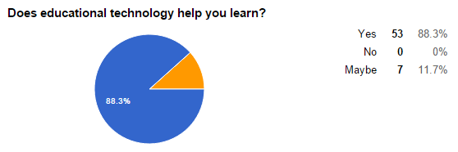
Figure 1. Survey Q5

In regards to the overall student perceptions of a blended learning environment, the researcher wanted each student to understand the word “perceptions” without asking the researcher for clarification of the word. With that being understood, the word “perceptions” was replaced in the survey with the word “feelings.” Below are survey findings that heavily favor a strong and positive feeling towards using educational technology at home and school.
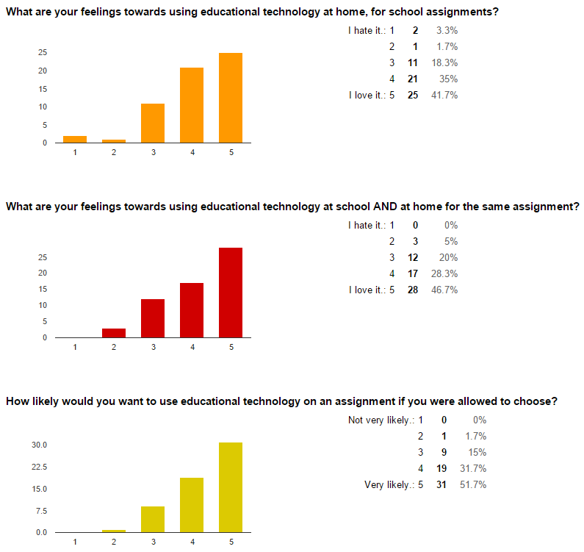
Figure 2. Survey Questions 6 - 8

The results from Figure 2 all point towards students feeling overly positive towards using technology at home and/or school and 83% of students would choose to use educational technology on an assignment if allowed to choose. Survey responses are leading the researcher to believe that students have positive feelings towards using technology in the classroom, along with the traditional face-to-face model. The final survey question asks the middle school student what their actual perceptions are on a blended learning environment. Below are the results in Figure 3.
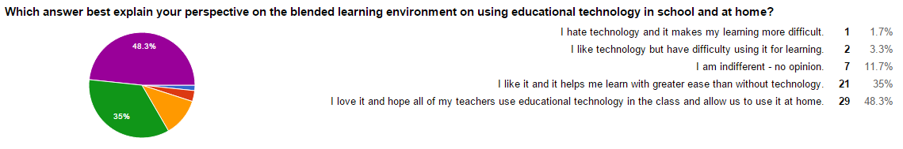
Figure 3. Survey Question 11

As the data clearly shows, only 3 students out of 60, or 5% of students have a difficulty using technology for learning or hate technology because it makes their learning more difficult. On the flip side of that data, 83% have strong positive feelings towards a blended learning environment that uses educational technology in school and at home. 11.7% (7 out of 60) of students felt indifferent towards a blended learning environment and selected that option in the survey.
Although this research study was only conducted with a small sample of students for the survey, two interviews with middle school students, and one classroom observation, in this case, the numbers do not lie. Middle school students have a strong and positive perception of a blended learning environment, and when given the chance, the strong majority of students will choose to use educational technology to start, continue, or complete an assignment.

Chapter 5

Discussion
The research of this case study was meant to obtain an understanding of what middle school students’ perceptions were in regards to a blended learning environment. Previous research on blended learning, as reference in this study, stated this method of instruction has multiple benefits for the teachers and students that operate within this environment. Napier, N. P., Dekhane, S., & Smith, S. (2011) explain that in their research of college students in a hybrid class, that no student rated the hybrid lower than 3 on a scale of 1-5 for all survey questions. All of the college level students approve of a hybrid course (or blended learning). Gecer, A., & Dag, F. (2012) explain that the college students of a blended learning environment research study conducted stated that the assignments and projects increased their learning responsibilities. There is little research available in terms of what middle schools students’ perceptions and overall feelings towards a blended learning model are. With that, at the conclusion of this research, many of the previous findings in those research studies share similar findings with this research study. It became very clear, after the data collection and coding were completed, that middle school students enjoy using technology to drive their learning and prefer a blended learning environment.

Conclusions
Creswell (2012) believes that when reporting the conclusions of a research study, the reporting must be easy to understand and easy to read so that there are not any misconceptions with any of the conclusions. With that in mind, the middle school students observed, interviewed, and surveyed had a strong positive perception of a blended learning environment. Their overall positive perceptions of blended learning were documented and apparent through the online survey where 83.4% of students would choose to use educational technology on an assignment if they were allowed to choose. With the overall research question of what middle school students’ perceptions are about blended learning, 86.7% were in favor of it and 13.3% of students surveyed identified themselves as indifferent. 0% of students provided a negative feeling or perception about using educational technology in school.
Although 100% of students share a positive perception of blended learning, this data should not be confused with 100% of middle school students agreeing that 100% of a blended learning environment is always how they would choose to learn. Through carefully coding through the student interviews, both interviewees expressed concern when using different forms of technology from class to class. The students believed that although technology helped them in their learning, learning and using new and different technologies made learning and the completion of assignments more difficult and overall a hindrance within the learning process.
Overall, the findings from this case study provide evidence that middle school students’ perspectives of a blended learning model of learning is positive. The participants in this study, although just from one rural school in Georgia, have their shared voices heard that a blended learning environment, according to them, is a positive and preferable learning environment. The question remains, with educators, is will the educators themselves hear what their students are saying?
Implications
From the conclusive findings of students’ perspectives on blended learning, middle school teachers and administrators may need to rethink the method of information acquisition by their students. Technology integration continues to grow each year and with the State of Georgia’s goals to have all students testing online in the next few years (as of now), it is imperative that students become more than familiar with technology in the classroom for learning opportunities.
The findings of this study can be used to assist educators to if not implement a blended learning environment, to at least discuss with the students the possibility of a blended learning environment. The students are reporting that they believe educational technology assists them in their learning, and would choose to use it if given the choice. If schools and teachers are looking for effective ways to engage students within the learning environment, this research can assist them in their quest to make positive changes with content delivery.
Recommendations
Administrators and teachers, along with students, need to come to the table and discuss the ways and methods students like to learn. From the findings of this research, there is a highly likely chance that technology will be a major factor for the middle school students, in how they the students would like to learn. If anything, this research can be used to assist in further research at other middle schools.
Surveying students, teachers, and parents, may also shed light into confirming what this research study has produced, that students have a very strong positive perception of blended learning. By allowing students to become a part of the process in which they can decide how they learn may lead to further student engagement as they asked for and received a technologically driven educational experience.
It may be challenging to implement a blended learning environment without proper training of educators and administrators. The results also indicated that 91.6% of students believed their teacher used educational technology effectively, which may directly align with their overall perception of a blended learning environment. If a blended learning model is desired, training and support for the teachers, and students, would be our strongest recommendation.

References
Conceptual Framework - Sage Publications. Retrieved September 20, 2015, from http://www.sagepub.com/sites/default/files/upm-binaries/48274_ch_3.pdf.

Creswell, J. W. (2012). Educational research: Planning, conducting, and evaluating quantitative and qualitative research (4th ed.) Boston: Person.

Ethics in Research - Web Center for Social Research Methods. (2006). Retrieved from http://www.socialresearchmethods.net/kb/ethics.php.

Garrison, D. & Kanuka, H. (2004). Blended Learning: Uncovering its transformative potential in Higher education. Internet and Higher Education, 7. 95-105.

Gecer, A., & Dag, F. (2012). A Blended Learning Experience. Educational Sciences: Theory And Practice, 12(1), 438-442.

Home - Blended Learning - Northern Arizona University. (2013). Retrieved from http://nau.edu/Blended-Learning/.

IT's Elementary! Integrating Technology in the ... - ISTE. (2015). Retrieved from http://www.iste.org/docs/excerpts/itsele-excerpt.pdf.

Lincoln, YS. & Guba, EG. (1985). Naturalistic Inquiry. Newbury Park, CA: Sage Publications.

Napier, N. P., Dekhane, S., & Smith, S. (2011). Transitioning to Blended Learning: Understanding Student and Faculty Perceptions. Journal Of Asynchronous Learning Networks, 15(1), 20-32.

Oh, E. and Park, S. (2009) “How are universities involved in blended instruction? Educational Technology and Society, Vol. 12, No. 3, pp. 327-342.

Oliver, M. and Trigwell, K. (2005) “Can blended learning’ be redeemed?” E–Learning, Vol. 2, No. 1, pp. 17-26.

Sloman, M. (2003). Training in the age of the learner. London, UK : Chartered Institute of Personnel and Development.

What is Blended Learning? | Blended Learning Toolkit. (2014). Retrieved from https://blended.online.ucf.edu/about/what-is-blended-learning/.

What is Research Design? 1. (2014). Retrieved from https://www.nyu.edu/classes/bkg/methods/005847ch1.pdf.

What Is Successful Technology Integration? | Edutopia. Retrieved September 20, 2015, from http://www.edutopia.org/technology-integration-guide-description.
APPENDICES

Appendix A
Initial Email to Contact Participants
Dear Student,

You have been selected to participate in a research study. This research study will be conducted by me, Chad DeWolf, a teacher at Madison County Middle School. I am interested in learning about what students think about using technology in the classroom, at home, really anywhere when it involves student learning. Please know that this will occur during school hours and inside the school itself. No extra time for your day will be required. Only two students will be selected to be interviewed, as the others, including the ones interviewed, will take a short online survey.

A permission form to participate in this research study will be sent home with you for you and your parent to sign and return. Only students who return the permission form will be allowed to participate in this research study.

Thank you,

Mr. DeWolf

Appendix B
Informed Consent

The following student _____________________________ has been chosen to participate in a research study conducted by Mr. Chad J. DeWolf. The purpose of this research study is to identify student perceptions of a “Blended Learning” environment in a middle school setting. All identifiable information will remain anonymous which will protect the student’s privacy. This research study will occur during the month of September, 2015. A minimal amount of time during a single school day will be needed. This time should not interfere with the school day in any major way.

_____ I give my child permission to participate in this research study.

_____ I do NOT give my child permission to participate in this research study.

STUDENT NAME: ________________________________________________________

STUDENT SIGNATURE: ___________________________________________________

PARENT NAME: __________________________________________________________

PARENT SIGNATURE: _____________________________________________________

Appendix C
Interview Prompts

- Tell me about how you use technology in the classroom and at home for your content (English, Math, Science, and Social Studies) classes in 8th grade.
- Tell me about how technology is used in your classes.
- Tell me about an experience with technology that you had the required you to use the same technology inside and outside of school.
- How do you feel about the integration of educational technology for usage inside and outside of school? Can you explain a little bit more?
- How do you feel when you have to use educational technology outside of school? Why? If you could change something about this process, what would it be and why?
- Discuss what you think about Google Apps for Education in regards to using it during a typical assignment that requires usage in and out of school.

Appendix D
Interview Transcripts
STUDENT A
Me: Alright, here’s the first question, sir. Can you tell me about how you use technology in the classroom, and at home, with your four main subjects – English, Social Studies, Math, and Science?
A: I’ll use it to research topics that we are learning in class. I generally use technology because it’s easier and faster than going to a library or researching it on paper.
Me: Okay, thank you. Second Question. Tell me about how technology, how is technology used inside your classes, in a typical, you know, class period.
A: We generally use it for some assignments, and quizzes. We’ll use it for book reports, and um, and papers instead of writing it on actual paper.
Me: Tell me about an actual experience with technology that you had that required you to use the same technology outside of the classroom. So you use technology in the classroom for an assignment, and you had to use it outside the classroom, the same technology, is there anything that comes to mind?
A: I’ll use Google Docs and PowerPoint at my house and in the classroom for projects and assignments.
Me: And how did that go?
A: It normally goes well.
Me: How do you feel about the integration of educational technology for use inside the classroom and outside? Do you enjoy it or dislike it? Tell me about how you feel about using technology inside the classroom, and outside the classroom, for learning.
A: I think it’s a good idea but for some students it may be distracting for them because, I mean, technology does make things easier, for some people, and it’s faster than general paper books, but it is distracting to some people.
Me: Okay. Can you explain how it could be distracting?
A: Well, there’s the whole internet (pause for announcements over the intercoms)
Me: Sorry about that, you were talking about how it might have been a distraction for others?
A: Well you’re using the whole internet, and you’re on a webpage, sometimes it has other links, or you think of something else you might want to look up, so you may do that instead of focusing on the topic at hand.
Me: Okay, thank you. Ahh next question. How, and we have two more, how do you feel when you have used educational technology outside of school? How do you feel about it? You personally.
A: I think it’s a good idea because I don’t, like, go into the library because it takes a bit more work than using a computer.
Me: Okay, why do you think it’s a good idea? Do you have another way to explain it besides not going to a library? Does it do something for you that makes life easier?
A: It’s quicker than other methods.
Me: Okay. If you could changes something about using technology outside of the classroom, what would it be? If you could change anything?
A: Related to school work?
Me: Mmhmm.
A: I think it’s fine the way it is.
Me: Okay. And lastly, please discuss what you think about Google Apps for Education, the Google that is used in the classroom, in regards to using it during a typical assignment that requires to use it inside the classroom and outside the classroom. How does it work for you?
A: Google Apps is all in the cloud so I can open it whenever and wherever, so that’s helpful – I don’t need to be a certain place to open it. You can research it, there’s the classroom app which has been really helpful with some of my classes. There’s the documents which I use assignments for in classes as well.
Me: Sir, thank you for your time. I appreciate it, and that is all.
A: Thank you.

STUDENT B
Me: Okay. So we have six questions that I am going to ask you and as soon as I’m done, think about it and answer as best you can. Are you ready?
B: Mmhmm.
Me: Okay, here we go. Tell me about how you use technology in the classroom, and at home, for all of you content classes – English, Math, Science, and/or Social Studies. So how do you use technology in the classroom, and at home, for your classes?
B: Well, I use them to type papers and I use Google Docs to type papers, and in (teacher’s name) class we use a lot of Word and Google Docs to complete our assignments.
Me: Okay. Can you tell me how technology is used inside your classes, so inside the building?
B: We use it for school projects, like to type up a document, or a, how do you say it, um… a research paper and to type up notes and stuff.
Me: Okay. Do you use technology for anything else besides notes and papers for anything else?
B: To make graphs and stuff.
Me: Okay. Please tell me your experience that you had with technology, that had you use the same technology, inside the classroom, and then the same technology, outside of the classroom? So did you have an assignment that had you use the same technology inside the classroom and you had to use it at home as well?
B: Yes.
Me: Can you tell me about that experience?
B: Well, (teacher’s name) classroom, when we have a lesson and work, and we don’t finish it, you have to go into your drive and finish it. So you use your drive to access all your files, and so far it’s worked.
Me: Okay. How do you feel about the integration of educational technology for uses inside the classroom and outside? So how do you feel about using technology as a main part of the classroom learning experience, and at home as well?
B: It helps me because it helps me concentrate and get more done in time than writing stuff.
Me: How does it help you concentrate?
B: Um, if I have to concentrate on what I’m typing it helps me think more about the topic and help me understand it better.
Me: Two more. How do you feel when you have to use educational technology outside of the school?
B: I like it, but it’s overwhelming sometimes because you have to go through these different programs to get your work done, but it helps… it’s better than writing for me.
Me: On paper?
B: Mmhmm.
Me: So if you could change something about educational technology outside of the classroom what would it be?
B: Just have everyone do something in the same program so you don’t have to jump from one program to another.
Me: Thank you. Last question. Discuss what you think about Google Apps for Education, all the Google stuff you use, in regards to using it during a typical assignment that requires you to use it inside the school and outside the school? So what do you think about using that for an assignment you need to do inside and outside of school?
B: Um, I think it’s a good idea, cause you have to, um, it’s a good idea because then you, then you get to do stuff outside of school so you don’t have to worry about doing it in school so you’ll have more time to complete the assignment.
Me: Well, thank you for your time, and I appreciate it.

Appendix E
Observation Notes
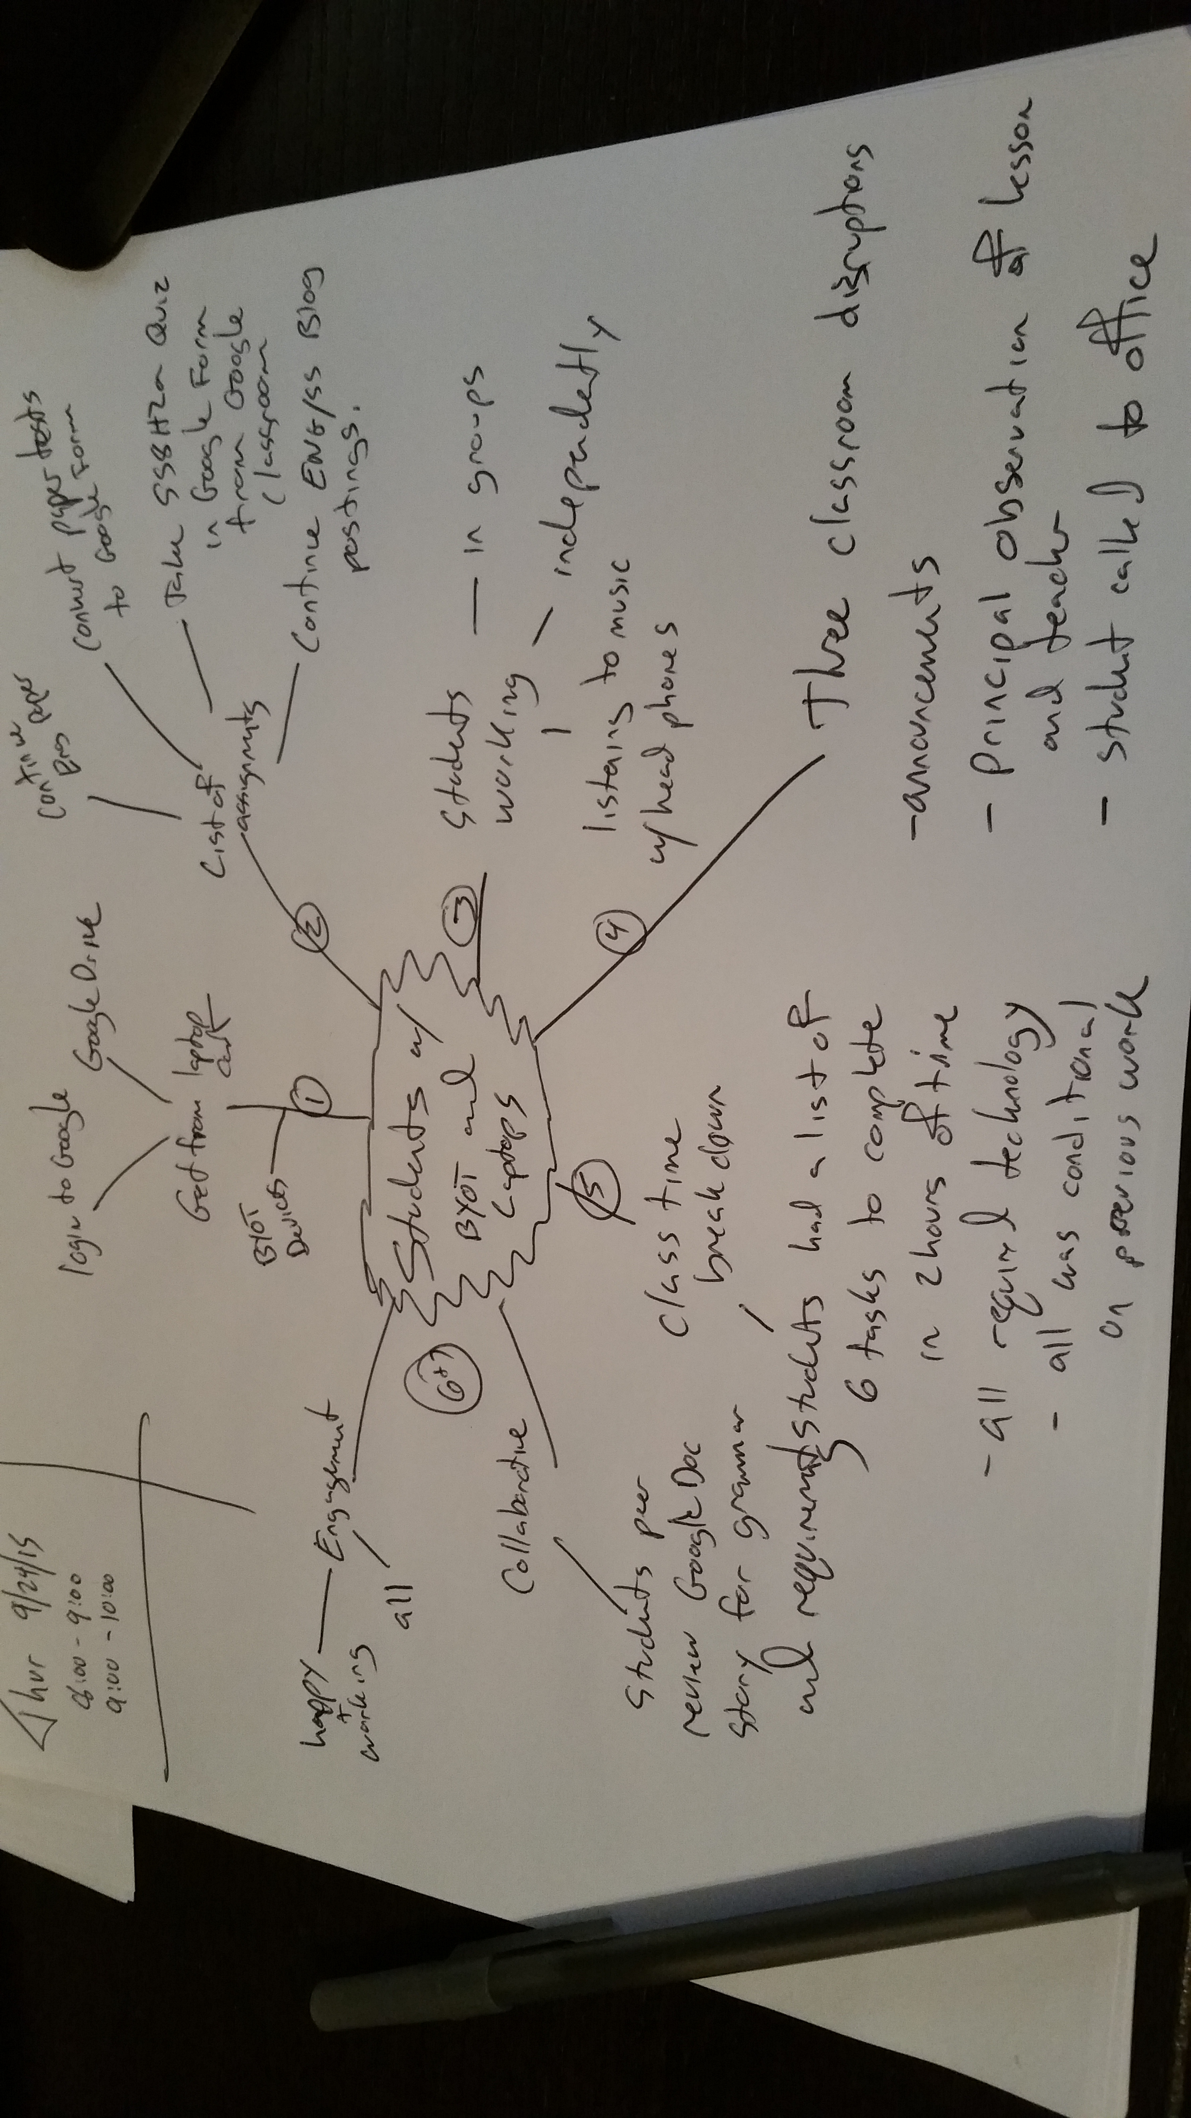

Appendix F
Sample Document
Student Work – Collected on day of observation. This writing was completed at home before the date of the observation, and continued during the observation.
SS8H1.b Queen Elizabeth takes Spanish Ships-

I was walking around my house on a cold foggy night and noticed a crack in the ground. I wanted to get a closer look so I stood on it jumped up and down 3 times and in a blink of an eye I was falling into a deep black hole and it felt endless. I quivered at the sight when I got to the bottom. There was pool of water with huge shark waiting on me it opened its mouth and swallowed me whole. This wasn't a normal shark stomach because I woke up in what seemed like the middle of the woods and saw many Indians talking with Spaniards about trading things for gold. I felt like I was trapped in a social studies book and there was no way out. The Indians turned around and said something that sounded like konnichiwa and I just nodded my head. The Indians had bow and arrows and were having some target practice to show the Spaniards their target skills. It was a good thing that I took Spanish class because one of the Spaniards turned around and asked who I was and started to threaten to kill me if I was a spy. I told him that I was exploring and I got lost and couldn't find my way back to my ship (which was a lie but I didn't want to die in the middle of the woods). And he slowly released my collar. I started listening to the latest news on how the Spaniards were going back for 3 days to get supplies and that I could come with them. So, the next day we started walking east and they said it would ONLY take from dusk till dawn!! I felt like was going to pass out at the end of the day because I had never walked so far and so long in my life. It was weird that the Spaniards didn't even break a sweat! Finally we got to the navigated beach area and there were no ships to be found and boy was I upset! I needed something to calm me down so I didn't have a panic attack

James Oglethorpe (J Oggs) and the Indians

This is a story all about how I was walking in the woods and saw a unicorn and we flew off to a magical sparkled place with….INDIANS!!!! It wasn't magical or sparkled :(......I lied. This place was HORRIBLE!!! There was no running water, nowhere to sleep (except the ground of course)

Appendix G

Interview Transcripts (Coded)
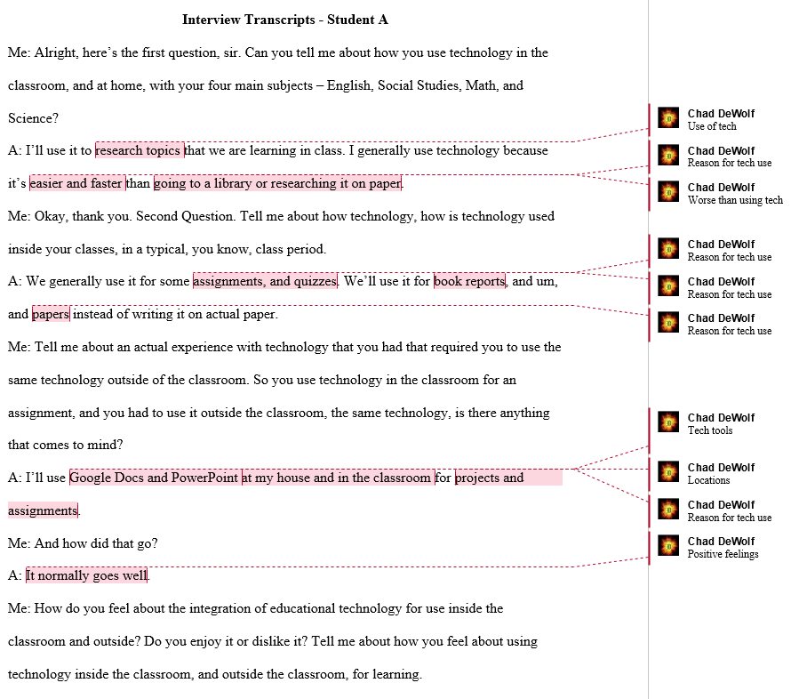
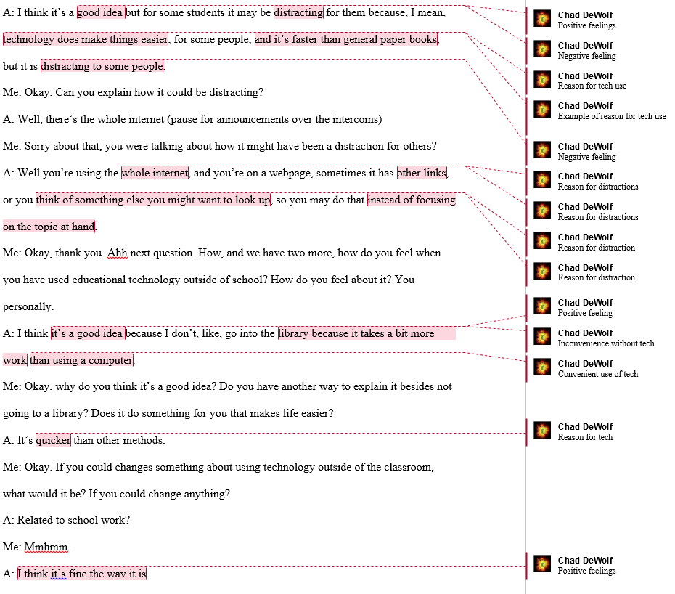
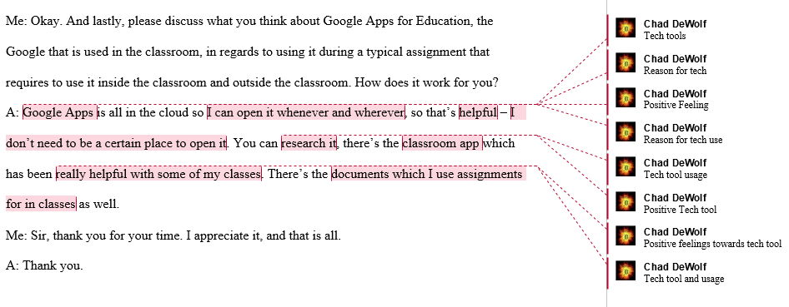
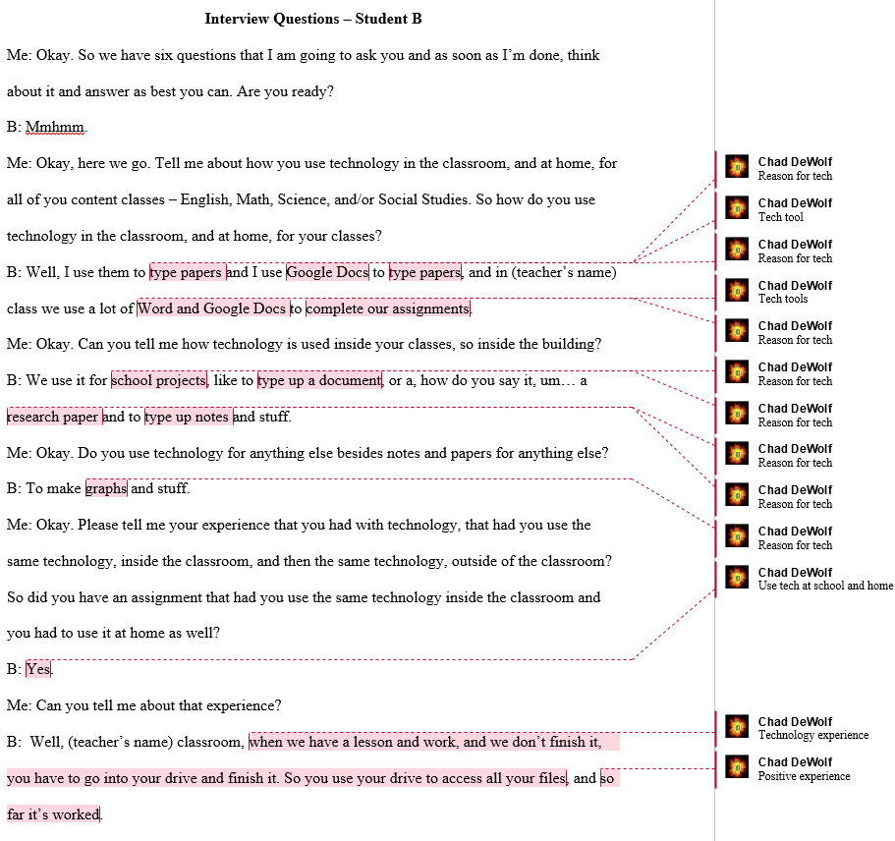
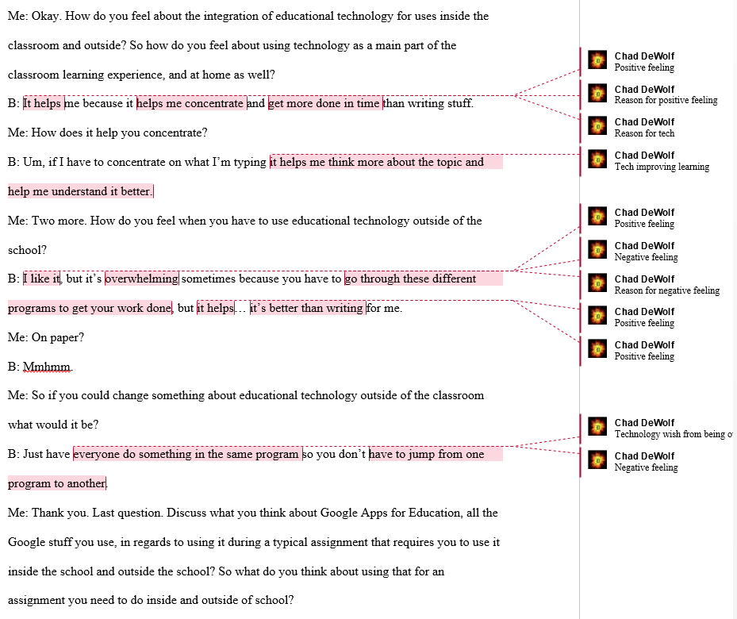
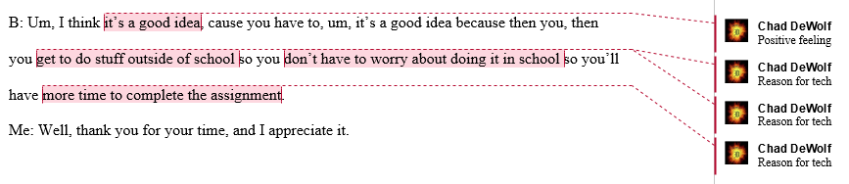

Appendix H

Observation Notes (Coded)
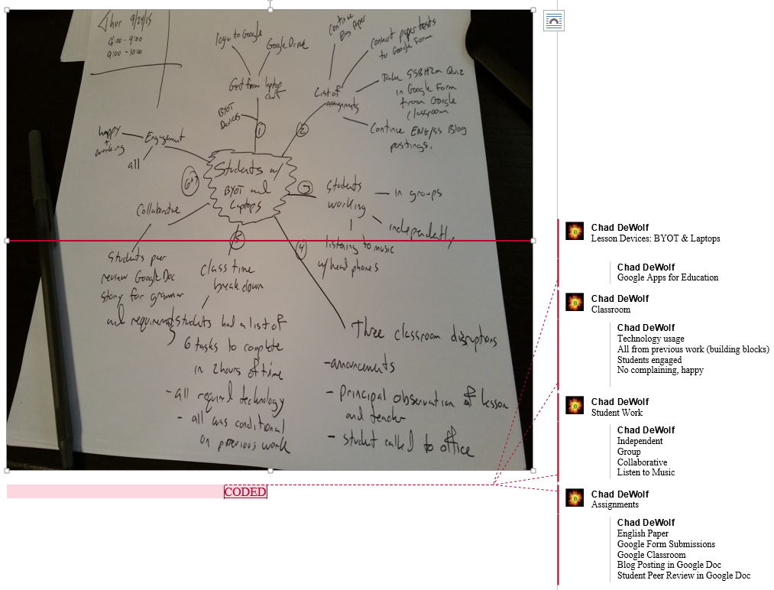

Appendix I

Sample Document (Coded)

The following sample document collected from the lesson and observation was created by an eighth grade student. It is a yearlong work in progress that is written in class and at home. It cannot be coded due to it not being relevant towards the research question pertaining to a student’s perspective on a blended learning environment.

SS8H1.b Queen Elizabeth takes Spanish Ships-

I was walking around my house on a cold foggy night and noticed a crack in the ground. I wanted to get a closer look so I stood on it jumped up and down 3 times and in a blink of an eye I was falling into a deep black hole and it felt endless. I quivered at the sight when I got to the bottom. There was pool of water with huge shark waiting on me it opened its mouth and swallowed me whole. This wasn't a normal shark stomach because I woke up in what seemed like the middle of the woods and saw many Indians talking with Spaniards about trading things for gold. I felt like I was trapped in a social studies book and there was no way out. The Indians turned around and said something that sounded like konnichiwa and I just nodded my head. The Indians had bow and arrows and were having some target practice to show the Spaniards their target skills. It was a good thing that I took Spanish class because one of the Spaniards turned around and asked who I was and started to threaten to kill me if I was a spy. I told him that I was exploring and I got lost and couldn't find my way back to my ship (which was a lie but I didn't want to die in the middle of the woods). And he slowly released my collar. I started listening to the latest news on how the Spaniards were going back for 3 days to get supplies and that I could come with them. So, the next day we started walking east and they said it would ONLY take from dusk till dawn!! I felt like was going to pass out at the end of the day because I had never walked so far and so long in my life. It was weird that the Spaniards didn't even break a sweat! Finally we got to the navigated beach area and there were no ships to be found and boy was I upset! I needed something to calm me down so I didn't have a panic attack

James Oglethorpe (J Oggs) and the Indians

This is a story all about how I was walking in the woods and saw a unicorn and we flew off to a magical sparkled place with….INDIANS!!!! It wasn't magical or sparkled :(......I lied. This place was HORRIBLE!!! There was no running water, nowhere to sleep (except the ground of course)

Appendix J

Code Book
Table 1.0 Codebook
Code | Information
Negative feelings | Distracting, overwhelming, go through different programs, jump from one program to another
Positive feelings | It normally goes well, good idea, fine the way it is, really helpful with some of my classes, it’s worked, I like it
Reason for distractions | Whole internet, other links, think of something else you might want to look up, lack of focus on topic
Reason for tech use | Easier and faster, assignments and quizzes, book reports, papers, quicker, open it whenever and wherever, helpful, don’t need to be in a certain place to open it, type papers, complete assignments, projects, research, notes, graphs, it helps me concentrate, get more done in time, helps me think about the topic and understand it better, get to do stuff outside of school, don’t have to worry about doing it in school, more time to complete assignments
Technology experience | When we have a lesson, and work, and we don’t finish it, you have to go into your drive and finish it, so you use your drive to finish it.
Tech Tools | Google Apps, PowerPoint, Research, Classroom App, Google Documents, Word,
Technology wish | Everyone do something in the same program
Worse than using tech | Going to the library or researching it on paper

Appendix K

Patterns in the Data

Table F
Category | Code | Best quote from data to represent associated code
Feelings About Technology | Negative Feelings | “… but it is distracting to some people.”
 | Positive Feelings | “… there’s the classroom app which has been really helpful with some of my classes.”
 | Reason for distraction | “Well, there’s the whole internet, and you’re on a webpage, sometimes it has other links, or you think of something else you might want to look up, so you may do that instead of focusing on the topic at hand. “
Technology | Reason for tech use | “I generally use technology because it’s easier and faster than going to a library or researching it on paper.”
 | Technology experience | “When we have a lesson, and work, and we don’t finish it, you have to go into your drive and finish it, so you use your drive to finish it.”
 | Tech tools | “Google Apps is all in the cloud so I can open it whenever and wherever, so that’s helpful – I don’t need to be in a certain place to open it.”
 | Technology wish | “Just have everyone do something in the same program so you don’t have to jump from one program to another.”
 | Worse than using technology | “I generally use technology because it’s easier and faster than going to a library or researching it on paper.”

Both participants responded with technology usage in the classroom as easier and faster while at the same time both brought up that it could be distracting at the same time. The interviewees explained that they believe technology in the classroom and at home is a good idea and when used, is helpful to the completion of their classwork. It is interesting that both participants used the same word “distracting” when talking about the negative of using technology in class and at home.

Overall, the interviews confirms the findings in the studies of the literature reviews that students like the use of technology in the classroom, and would prefer to use it over traditional methods (paper and pencil) at home if given the chance.

